HIMANSHU RAWAT



EXPERIENCE

# brillica services

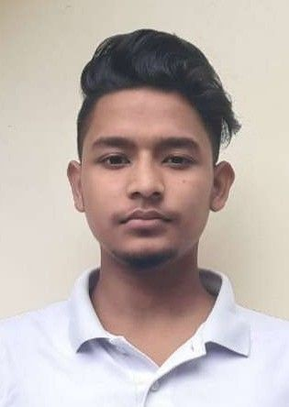internship

Iam still working as an intern and student in brillica services



EDUCATION

# scholar'shome

10

70.6%

# scholar'sHome

12

66%



CONTACT

2 Feb 2022 - 2 Dec

2022

2018

2020



 7505026843

 [himanshurawat25691@gmail.com](mailto:himanshurawat25691@gmail.com) 10/02/2002

 https://[www.linkedin.com/mwlite/in/himanshu-](http://www.linkedin.com/mwlite/in/himanshu-) rawat-046a35222



OBJECTIVE

My goal is to become associated with a company

# H.N.B

B.C.A 70



PROJECTS

# Text manipulater

This project is based on react js and vanilla js.

HERE YOU CAN MANIPULATE YOUR TEXT WITH EASE. HERE IS THE LINK TO MY

PROJECT:https://github.com/Himanshu2021rawat/H.R-Textmanipulations

# random image generator using Fetch Api

Here you can generate random images of animals

This project is based on vanilla javascript fetch Api function here is the link:https://github.com/Himanshu2021rawat/Random-Fox-Dog-Image-generator

# chat app

2023

where I can utilize my skills and gain further experience while enhancing the company’s productivity and reputation.



SKILLS

Good communication skills HTML,CSS

javascript,reactjs,nodejs,mysql

github java(beginner) pyhton(beginner) C++,C

Hardworking,determine to my work ,worked as a group leader in my school project with my friends

powebi,ms excel,msword

This chat app is created with the help of javascript framework like nodejs and socket.io here is the link: https://github.com/Himanshu2021rawat/Chat-App

# java random numbers generator

Project based on core Java here is the link:https://github.com/Himanshu2021rawat/Java- Guess-RandomNumber

# Encryption-decryption-Using-Python-tkinter

https://github.com/Himanshu2021rawat/Encryption-decryption-Using-Python-tkinter.py